Pertemuan 9
Nama | Favian Naufal Al Farrel
NIM | 264107020200
Kelas & No. Absen | TI – 1C / 12
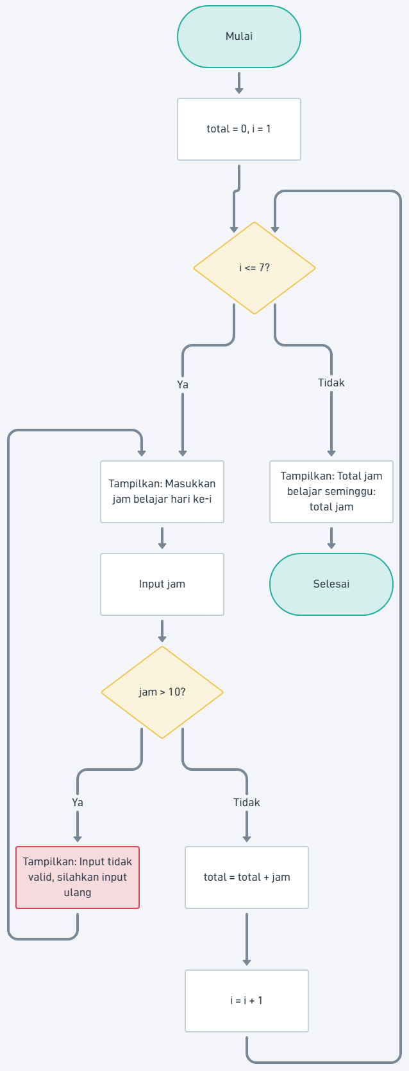
Latihan 1
SET total = 0
FOR i FROM 1 TO 7 DO
DO
OUTPUT "Masukkan jam belajar hari ke-i"
INPUT jam
IF jam > 10 THEN
OUTPUT "Tidak mungkin! Input ulang"
END IF
WHILE jam > 10
total = total + jam
END FOR
OUTPUT total
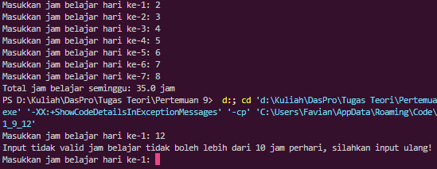

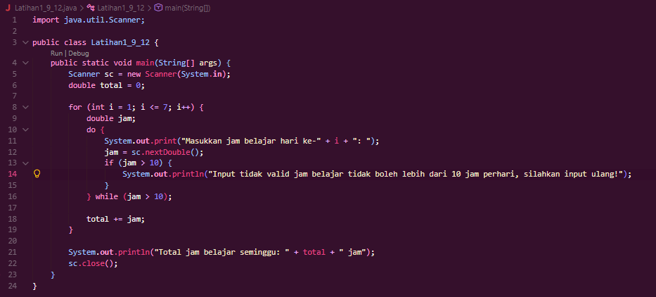

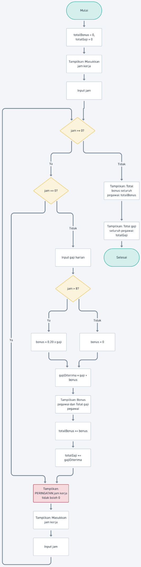
Latihan 2
import java.util.Scanner;

public class Latihan2_9_12 {
public static void main(String[] args) {
Scanner sc = new Scanner(System.in);
double totalBonus = 0;
double totalGaji = 0;

System.out.print("Masukkan jam kerja (negatif untuk berhenti): ");
double jam = sc.nextDouble();

while (jam >= 0) {
if (jam == 0) {
System.out.println("PERINGATAN: Jam kerja tidak boleh 0! Silakan masukkan ulang.");
} else {
System.out.print("Masukkan gaji harian: ");
double gaji = sc.nextDouble();

double bonus = 0;
if (jam > 8) {
bonus = 0.20 * gaji;
}

double gajiDiterima = gaji + bonus;

System.out.println("Bonus pegawai: Rp " + bonus);
System.out.println("Total gaji pegawai (gaji + bonus): Rp " + gajiDiterima);

totalBonus += bonus;
totalGaji += gajiDiterima;
}

System.out.print("Masukkan jam kerja (negatif untuk berhenti): ");
jam = sc.nextDouble();
}

System.out.println("Total bonus seluruh pegawai: Rp " + totalBonus);
System.out.println("Total gaji seluruh pegawai: Rp " + totalGaji);
sc.close();
}
}
